**EE 301 HW2 Problem 7**

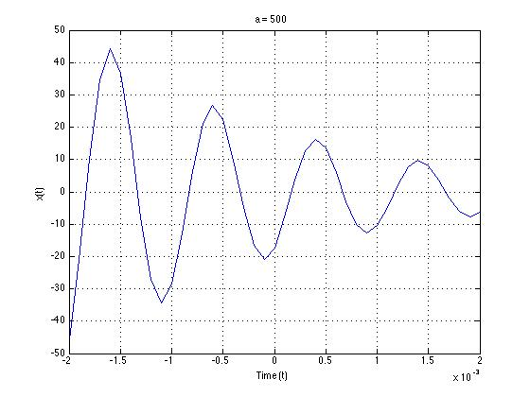

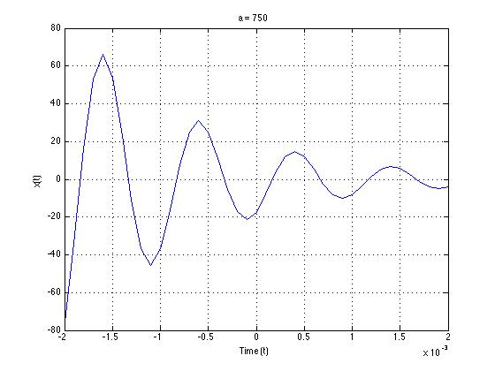

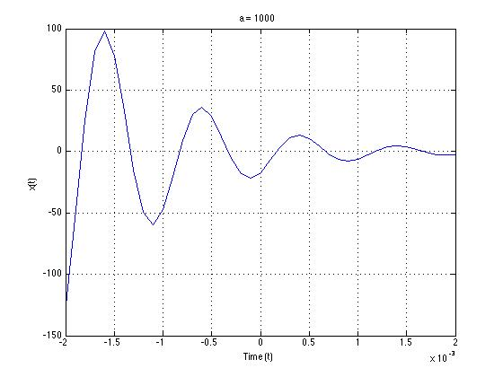

%EE301 HW2

clc

clear all

close all

%Change in time vector

dtau = 0.0001;

%Time vector

t=-2e-3:dtau:2e-3;

%Function

x=inline('20*sin(2*pi*1000*t-pi/3).*exp(-500*t)');

%Plotting x(t)

figure

plot(t,x(t));

hold all

grid

xlabel('Time (t)');

ylabel('x(t)');

title('a = 500');

The effect of varying *a* on the signal *x(t)* is seen on the damping of every different system on the graph. As *a* increases, the time it takes the system to damp decreases. Furthermore, the initial amplitude of the system is larger, but as time increases it damps faster.